Service Models responsibilities
As a service means which party will manage the particular layer and all the layers below.
- Software layer consists the application (application code and set) & the application data
- Platform layer means all the supporting software and the operating system required to host the application
- Infrastructure layer consists hardware the infrastructure and virtualization required to host the platform
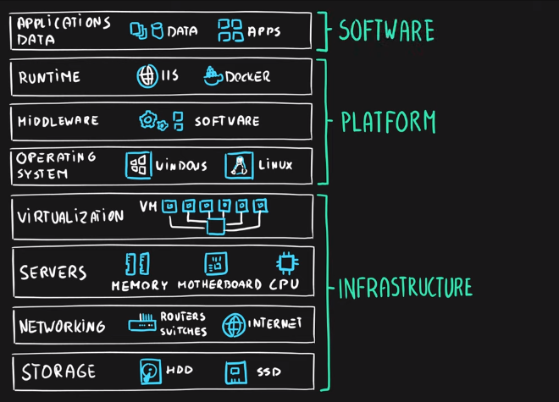

Layers of Each Data Job
Role | Primary Layers | Secondary Layers
Data Analyst | Application (Software) | Data (Software)
Data Engineer | Data (Software), Runtime (Platform) | OS/Storage (Platform/Infrastructure)
ML Engineer (MLE) | Application (Software), Runtime (Platform) | Middleware/Data (Platform/Software)

Responsibility Matrix
As such, following table represents responsibilities
Layer | On-Premises | IaaS | PaaS | SaaS
Application | You | You | You | Cloud provider
Data | You | You | You | Cloud provider
Runtime | You | You | Cloud provider | Cloud provider
Middleware | You | You | Cloud provider | Cloud provider
Operating System | You | You | Cloud provider | Cloud provider
Virtualization | You | Cloud provider | Cloud provider | Cloud provider
Servers | You | Cloud provider | Cloud provider | Cloud provider
Networking | You | Cloud provider | Cloud provider | Cloud provider
Storage | You | Cloud provider | Cloud provider | Cloud provider

